✅ AutoBoxing and AutoUnBoxing (Introduced in JDK 1.5)
Before JDK 1.5, primitive types and wrapper classes were completely different.
- You cannot assign a primitive directly to a wrapper.
- You cannot assign a wrapper directly to a primitive.
- Programmer had to manually convert.
Example (Before 1.5):
int x = 10;
Integer obj = new Integer(x); // Manual Boxing
Integer obj2 = new Integer(20);
int y = obj2.intValue(); // Manual Unboxing

From JDK 1.5 onwards, the compiler automatically performs these conversions.
This feature is called:
- AutoBoxing
- AutoUnBoxing

✅ What is AutoBoxing?
👉 Automatic conversion of primitive type into its corresponding wrapper object.
Example:
Integer i1 = 20;
What compiler actually does internally:
Integer i1 = Integer.valueOf(20);
✔ The compiler automatically calls valueOf() method.
✔ This process is called AutoBoxing.

✅ What is AutoUnBoxing?
👉 Automatic conversion of wrapper object into its corresponding primitive type.
Example:
Integer i1 = 10;
int i2 = i1;
What compiler actually does internally:
int i2 = i1.intValue();
✔ The compiler automatically calls xxxValue() method
✔ (intValue(), doubleValue(), booleanValue() etc.)
✔ This process is called AutoUnBoxing

✅ Wrapper Class Mapping Table
Primitive | Wrapper Class
byte | Byte
short | Short
int | Integer
long | Long
float | Float
double | Double
char | Character
boolean | Boolean

✅ Important Missing Points (Very Important in Interviews + Real Projects)
1️⃣ AutoBoxing Uses Caching (Integer Cache)
Integer a = 100;
Integer b = 100;
System.out.println(a == b); // true
Why?
Because Integer.valueOf() uses Integer Cache for values from -128 to 127.
But:
Integer a = 200;
Integer b = 200;
System.out.println(a == b); // false
Outside cache range → different objects.
⚠ Always use .equals() to compare wrapper objects.

2️⃣ NullPointerException Risk in AutoUnBoxing ⚠
Integer i = null;
int x = i; // NullPointerException
Why?
Because compiler converts it to:
int x = i.intValue(); // null.intValue() → NPE
👉 Very common real-time production issue.

3. Why Wrapper Classes Are Needed?
Collections work only with objects:
List<int> ❌ // Not allowed
List<Integer> ✅
That is why AutoBoxing is very useful with:
- Collections
- Generics
- Streams
- Optional
- Hibernate / JPA entities

4. About Deprecated Constructor
Integer i1 = new Integer("10"); // Deprecated (since Java 9)
✔ Deprecated because:
- It always creates a new object
- It does NOT use caching
- valueOf() is preferred
Correct way:
Integer i2 = Integer.valueOf("10");

Eg: AutoBoxing_UnBoxing_Eg2
// go through the code.

Eg: AutoBoxing_UnBoxing_Eg3
//go through the code

Eg: AutoBoxing_Unboxing_Eg4
// go through the code
Eg: AutoBoxing_Unboxing_Eg5
// go through the code.

Eg: AutoBoxing_UnBoxing_Eg6
// go through the code

Eg: AutoBoxing_UnBoxing_Eg7
//go through the code

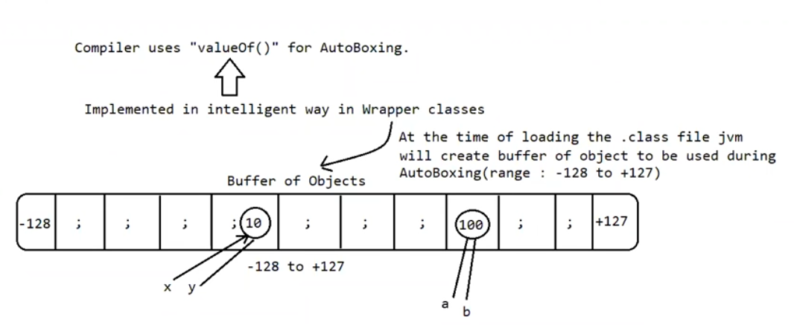
✅ 1️⃣ Why Compiler Uses valueOf() for Autoboxing?
When you write:
Integer i = 10;
Compiler converts it internally to:
Integer i = Integer.valueOf(10);
👉 It does NOT use:
new Integer(10); ❌
Because valueOf() is optimized (uses buffer/cache).

✅ 2️⃣ What Is This Buffer / Cache?
At the time of class loading, JVM creates a small pool (buffer) of wrapper objects.
For Integer, objects are pre-created for values:
-128 to +127
So JVM already has ready-made objects like:
Integer(-128)
Integer(-127)
...
Integer(0)
Integer(1)
...
Integer(127)
This improves:
- 🚀 Performance
- 💾 Memory usage

✅ 3️⃣ What Happens During Autoboxing?
When you write:
Integer x = 10;
JVM does:
Check cache:
Is 10 available in buffer?
YES → reuse existing object
NO → create new object in heap
Since 10 is inside -128 to 127:
👉 It reuses cached object.

✅ 4️⃣ Example to Understand Clearly
Integer a = 100;
Integer b = 100;
System.out.println(a == b);
✔ 100 is in cache range
✔ Same object reused
✔ Output → true

Now:
Integer a = 200;
Integer b = 200;
System.out.println(a == b);
❌ 200 not in cache range
❌ Two separate objects created
✔ Output → false

✅ 5️⃣ Cache Available For These Wrapper Classes
Wrapper Class | Cache Range
Byte | -128 to 127
Short | -128 to 127
Integer | -128 to 127
Long | -128 to 127
Character | 0 to 127
Boolean | true / false

✅ 6️⃣ Very Important Rule
If you use constructor:
Integer x = new Integer(10);
👉 JVM WILL NOT check cache
👉 Always creates new object in heap
So:
Integer x = new Integer(10);
Integer y = new Integer(10);
System.out.println(x == y); // false

✅ 7️⃣ Difference Between SCP and Integer Cache
Feature | String SCP | Integer Cache
Available for | String only | Wrapper classes
Triggered by | String literal | valueOf()
Uses new? | No | No
Purpose | Memory optimization | Memory + performance

✅ 8️⃣ Important Internal Logic (Simplified)
Inside Integer.valueOf(int i):
if (i >= -128 && i <= 127)
return cachedObject[i];
else
return new Integer(i);

🔥 Final Golden Summary
✔ Autoboxing uses valueOf()
✔ valueOf() uses cache
✔ Cache range: -128 to 127
✔ Constructor new bypasses cache
✔ == checks reference
✔ .equals() checks value

🎯 Most Important Interview Question
Why does this print true?
Integer a = 127;
Integer b = 127;
System.out.println(a == b);
But this prints false?
Integer a = 128;
Integer b = 128;
System.out.println(a == b);
Answer → Cache boundary crossed.

Eg: Buffer_Of_Object
// go through the code

Eg: AutoBoxing_UnBoxing_Eg8
// go through the code

Eg: AutoBoxing_UnBoxing_Eg9
// go through the code

Eg: AutoBoxing_UnBoxing_Eg10
🧠 Golden Rule First
Downcasting is allowed ONLY IF:
- Object was originally created as child
- Parent reference is holding that child object
- Then we cast back to child
If object is actually parent → ❌ Runtime error

✅ CASE 1 — Valid Upcasting + Valid Downcasting
✔ Object is Child
class Parent {}
class Child extends Parent {}
public class Test1 {
public static void main(String[] args) {
// Step 1: Create Child object
Child c = new Child();
// Step 2: Upcasting (safe)
Parent p = c; // Child → Parent
System.out.println("Upcasting done");
// Step 3: Downcasting (safe)
Child c2 = (Child) p; // Parent reference → Child
System.out.println("Downcasting done");
}
}
🔎 What Happens in Memory
c → [ Child object ]
p → [ Child object ]
Even though p is Parent reference,
the object inside is Child.
So downcasting is SAFE.

❌ CASE 2 — Invalid Downcasting (Your Case)
✔ Object is Parent
class Parent {}
class Child extends Parent {}
public class Test2 {
public static void main(String[] args) {
// Step 1: Create Parent object
Parent p = new Parent();
// Step 2: Try Downcasting
Child c = (Child) p; // ❌ Runtime error
}
}
🔎 What Happens in Memory
p → [ Parent object ]
You are trying to force:
Parent object → Child
That is impossible.
So JVM throws:
java.lang.ClassCastException

🎯 Compare Both Cases
Case | Object Created | Upcasting | Downcasting | Result
Case 1 | Child | Yes | Yes | ✅ Works
Case 2 | Parent | — | Yes | ❌ Runtime error

🔥 Very Important Concept
Java checks casting at:
- Compile time → Is relationship valid?
- Runtime → Is actual object compatible?

🧠 Remember This Forever
Reference type does NOT matter
Actual object type matters
Example:
Parent p = new Child(); // object = Child
Runtime object = Child
So downcasting allowed.
But:
Parent p = new Parent(); // object = Parent
Runtime object = Parent
So downcasting fails.

💡 Real-Life Analogy
Parent = Animal
Child = Dog
If actual object is Dog:
Animal a = new Dog();
Dog d = (Dog) a; // safe
But if actual object is Animal:
Animal a = new Animal();
Dog d = (Dog) a; // impossible
You cannot convert a generic Animal into Dog.

🚀 Final Perfect Understanding Sentence
You can downcast ONLY if object was originally child type.
If object is parent type, downcasting gives runtime error.

🧠 Why Do We Even Upcast?
Because Java supports:
- Polymorphism
- Generalization
- Writing flexible code
Example:
class Animal {}
class Dog extends Animal {}

✅ CASE 1 — Normal Situation (No Need of Downcasting)
Dog d = new Dog();
d.bark(); // Direct access
No casting needed.

🔥 CASE 2 — Where Downcasting Becomes Necessary
When we store Child object in Parent reference.
Animal a = new Dog(); // Upcasting
Now:
- Reference type = Animal
- Object type = Dog
From a, we can access only Animal methods.
If Dog has extra method:
class Dog extends Animal {
void bark() {}
}
Now this fails:
a.bark(); // ❌ Compile error
Because reference is Animal.
So we downcast:
Dog d = (Dog) a; // Downcasting
d.bark(); // ✅ Works

💡 So When Is Downcasting Compulsory?
Downcasting is required when:
- Object is created as Child
- Stored in Parent reference (upcasting happened)
- You want to access Child-specific methods

📌 Real Practical Example (Very Important)
class Shape {}
class Circle extends Shape {
void drawCircle() {}
}
public class Test {
public static void main(String[] args) {
Shape s = new Circle(); // Upcasting
// Now s can only access Shape methods
Circle c = (Circle) s; // Downcasting required
c.drawCircle(); // Access child method
}
}

❗ When Downcasting Is NOT Required
If reference is already Child type:
Circle c = new Circle();
c.drawCircle(); // No casting needed

❌ When Downcasting Fails
Shape s = new Shape();
Circle c = (Circle) s; // Runtime error
Because object is not Circle.

🎯 Final Understanding
Downcasting is required when:
- Parent reference is pointing to Child object
- You need Child behavior
- So you must cast it back

🧠 Golden Line to Remember
Downcasting is needed only when polymorphism hides child methods.

🚀 Most Real-World Scenario
When method returns Parent type:
Shape getShape() {
return new Circle();
}
Caller receives:
Shape s = getShape(); // Upcasting happened
If caller knows it's Circle:
Circle c = (Circle) s; // Downcasting needed

🔥 Final Answer to Your Question
When is downcasting compulsory?
✔ When child object is stored in parent reference
✔ And you want to access child-specific members
✔ That situation occurs because of upcasting (directly or indirectly)

